- February 2019 variant four task2:
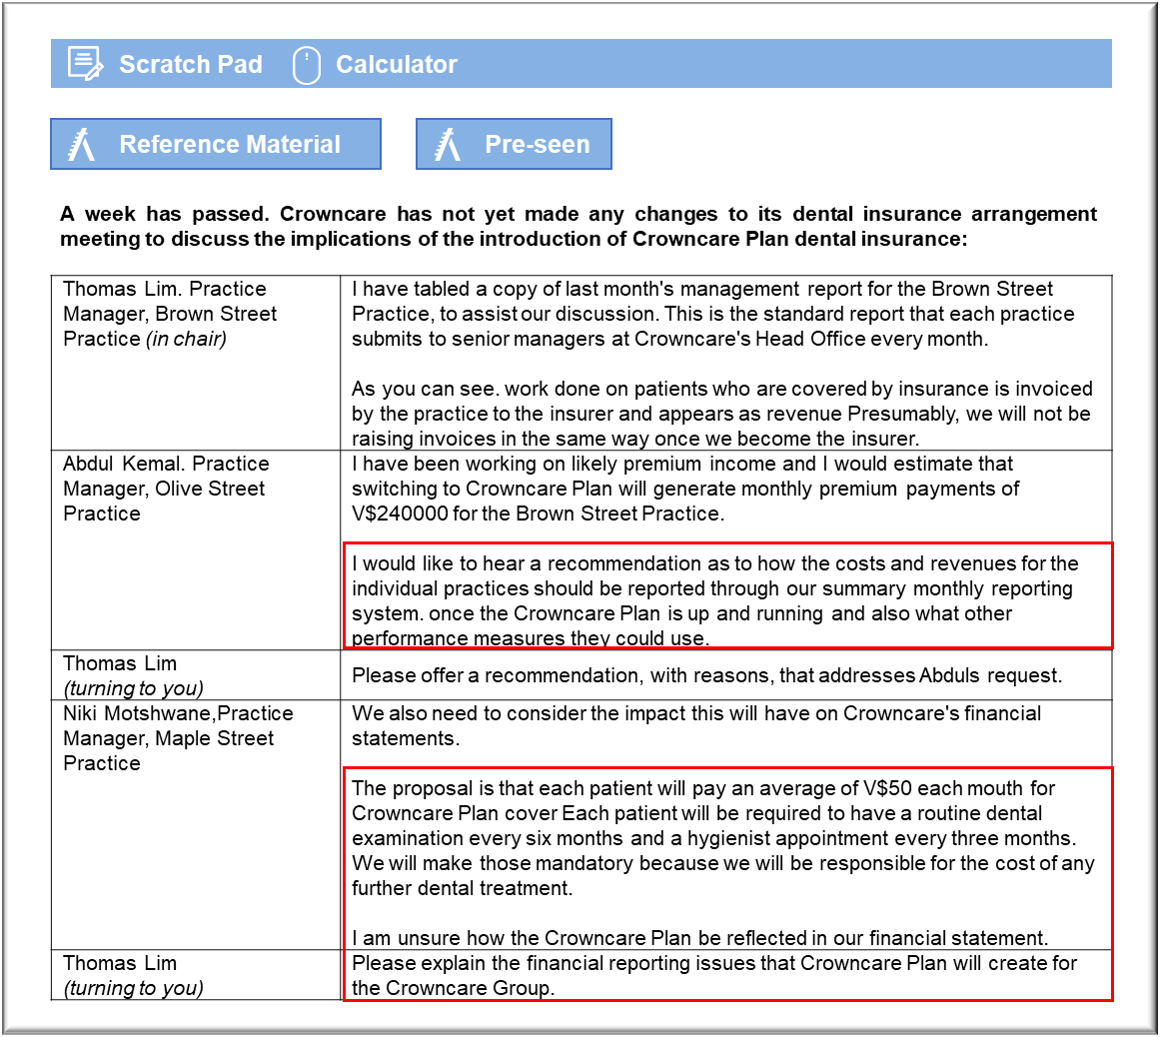
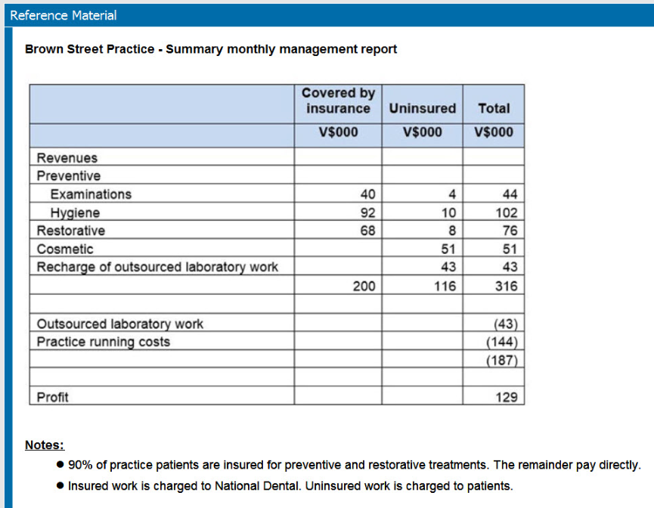
Budget reports

The report is intended to provide feedback on the commercial performance of the practices and that focus should continue.

The first issue that has to be addressed is whether to report the revenue from patient premiums. Arguably, it would be unhelpful to credit practices with that revenue because it is not directly under their control on a month by month basis. Practices should be informed of the numbers of patients joining and leaving the practice on a month by month basis because attracting and retaining patients is the key to Crowncare’s long-term success. Practices should also be informed of the numbers of patients who sign up for Crowncare Plan, at least during the transitional period, because practice staff will be in a position to encourage patients to take the insurance.

It is no longer particularly helpful to break revenues down between insured and uninsured. Dentists should not be given any reason to distinguish between patients on the basis of the manner that they pay for their care, otherwise they may perceive some pressure to withhold treatment from patients whose care is essentially being paid for by Crowncare itself. It may seem counter-intuitive to show fee income from patients who are covered by insurance, but providing patients with dental services is the basis of Crowncare’s business model.

The revenues should be broken down and subtotaled more clearly to show income from the three categories of preventive, restorative and cosmetic dentistry because these are important decisions from a commercial point of view. Preventive care is a key commercial activity, partly because all patients require regular dental checks and dental hygiene and so it reflects patient numbers who actively use the practice. Cosmetic treatment is discretionary and so practices should be encouraged to promote it as vigorously as possible. Laboratory work should also be broken down between restorative and cosmetic, partly to add further distinction between restoring damaged teeth and improving patients’ appearance. The distinction will also give a quick insight into the overall scale of the work being done under each category, alongside the associated value added in the surgery. It could, in any case, be argued that the sale of laboratory work is part of the practice’s revenue, even if it was sold at cost.

Financial reporting

Even though this policy is described as “dental insurance”, it is debateable whether it is really, or at least entirely, insurance in the conventional sense of paying a premium in order to transfer risk. Patients pay a monthly fee, in return for which they receive preventive care in the form of examinations and hygienist appointments that they would otherwise have to pay for in order to maintain their dental health, so there is no real transfer of risk. The premiumseffectively act as prepayments, at least in part, for this preventive treatment and so there is a question of the recognition of revenue.

The revenue from the prepayments for preventive care should be accounted for in accordance with IFRS 15 Revenue from Contracts with Customers. The revenue for the examinations and hygiene appointments should be recognised as and when the treatments are provided. The cash received from patients will, therefore, be credited to accruals as and when it is received.

There is a conventional insurance element in the sense that the policy covers any restorative dental work that they require while their policies are active. The policies appear to run from month to month and they can be cancelled at will, in which case the cover will also lapse. That raises the question of the liability that ought to be recognised with regard to this policy.

The insurance element of the payments will be recognised as revenue when the cover is earned. It appears that each monthly payment pays for a month’s cover in advance. That means that the premiums are prepayments when they are received, but they are transferred to revenue at the month end. Crowncare will also have to recognise the liabilities arising in respect of this cover as at the year-end. Given the short term nature of the policy, Crowncare will be able to limit the liabilities that it recognises to the cost of providing treatment under agreed treatment plans that have been established during the year, plus an element to cover claims that could arise from the insurance provided during the final month of the financial year.

Candidates could have referred to IFRS 4 Insurance Contracts in their discussion, and would have been awarded credit for doing so where relevant. They were not required to do so in order to earn full marks.

